Italian 2 Final Exam Topics/Review
Sapere/Conoscere
Sapere – to know facts/information, to know how to do something
Present tense conjugations:
so sappiamo
sai sapete
sa sanno
Conoscere – to be familiar with
Present tense conjugations:
conosco conosciamo
conosci conoscete
conosce conoscono
Present Progressive
-used to talk about what is happening right now – in this moment
-formed with stare and the gerund (compound tense)
-the gerund is formed by adding –ando (-are verbs) or –endo (-ere/-ire verbs)
Stare conjugations
sto stiamo
stai state
sta stanno
Irregular gerund forms:
Fare – facendo
Dire – dicendo
Bere – bevendo
-ex. – He is paying soccer –Lui sta giocando a calcio

Present tense (regular and irregular verbs)
 | io | tu | lui/lei | Noi | voi | loro
cantare | canto | canti | canta | cantiamo | cantate | cantano
leggere | leggo | leggi | legge | leggiamo | leggete | leggono
aprire | apro | apri | apre | apriamo | aprite | aprono
finire | finisco | finisci | finisce | finiamo | finite | finiscono

 | io | tu | lui/lei | Noi | voi | loro
essere | sono | sei | è | siamo | siete | sono
avere | ho | hai | ha | abbiamo | avete | hanno
andare | vado | vai | va | andiamo | andate | vanno
dare | do | dai | dà | diamo | date | danno
fare | faccio | fai | fa | facciamo | fate | fanno
stare | sto | stai | sta | stiamo | state | stanno
dovere | devo | devi | deve | dobbiamo | dovete | devono
potere | posso | puoi | può | possiamo | potete | possono
volere | voglio | vuoi | vuole | vogliamo | volete | vogliono
bere | bevo | bevi | beve | beviamo | bevete | bevono
sapere | so | sai | sa | sappiamo | sapete | sanno
dire | dico | dici | dice | diciamo | dite | dicono
uscire | esco | esci | esce | usciamo | uscite | escono
venire | vengo | vieni | viene | veniamo | venite | vengono

Present tense (reflexive verbs)
-Reflexive verbs – usually translate as “doing something for oneself”
-Reflexive pronouns:
mi ci
ti vi
si si
-Reflexive verbs are conjugated just like regular verbs – just with the addition of the reflexive pronoun before the conjugated verb
-ex. – Mi alzo alle sei – I get up at 6
Reflexive/Reciprocal verbs (all tenses)
-Reflexive verbs – “to do something for oneself”
-Reciprocal verbs – “each other”
-Conjugated in the same way, both use reflexive pronouns
-reciprocal verbs can only be plural
-when using passato prossimo, conjugated with essere
Direct object pronouns
-Direct object pronouns replace the direct object in a sentence
-Direct objects answer the questions WHAT? or WHO?
-Usually gets placed BEFORE the conjugated verb, except:
- with commands (attach)
-with dovere, potere, volere (can go before conjugated verb or can be attached to the infinitive)
-DOPs:
mi – me ci - us
ti – you vi – you (pl.)
lo – him/it (m.) li – them (m.)
la – her/it (f.) le – them (f.)
-Direct object pronouns LO and LA become L’ in front of avere – passato prossimo
- When using passato prossimo, the past participle must agree with the direct object pronoun
-ex.1 – I buy the books – Io compro i libri – Li compro
-ex. 2 – I bought the books – Io ho comprato i libri – Li ho comprati
Indirect object pronouns
-Indirect object pronouns replace the indirect object in a sentence
-Indirect objects answer the questions TO WHOM? or FOR WHOM?
-Usually gets placed BEFORE the conjugated verb, except:
- with commands (attach)
-with dovere, potere, volere (can go before or can be attached to the infinitive)

IOPs:
mi – to/for me ci – to/for us
ti – to/for you vi – to/for you (pl.)
gli – to/for him gli/loro – to/for them
le – to/for her
-No special rules for passato prossimo (no contractions, no agreement)
-When using LORO – must be placed after the verb
-ex.1 – I buy the books – Io compro i libri – Li compro
-ex. 2 – I bought the books – Io ho comprato i libri – Li ho comprati
Double object pronouns
 | LO | LA | LI | LE
MI | Me lo | Me la | Me li | Me le
TI | Te lo | Te la | Te li | Te le
GLI | Glielo | Gliela | Glieli | Gliele
LE | Glielo | Gliela | Glieli | Gliele
CI | Ce lo | Ce la | Ce li | Ce le
VI | Ve lo | Ve la | Ve li | Ve le
GLI | Glielo | Gliela | Glieli | Gliele
LORO | Lo…loro | La…loro | Li…loro | Le…loro
-follow rules for direct/indirect object pronouns
-to fill in chart, remember:
-mi, ti, ci, vi (i changes to e)
-gli and le combine with DOP by changing to glie
-with LORO, DOP comes first, then verb, then loro
Passato prossimo
-used to discuss completed actions/events in the past
-avere or essere + past participle

-avere -essere
ho abbiamo sono siamo
hai avete sei siete
ha hanno è sono
-Choose avere or essere by using THE HOUSE OF ESSERE or SUPERMAN DAVE T.
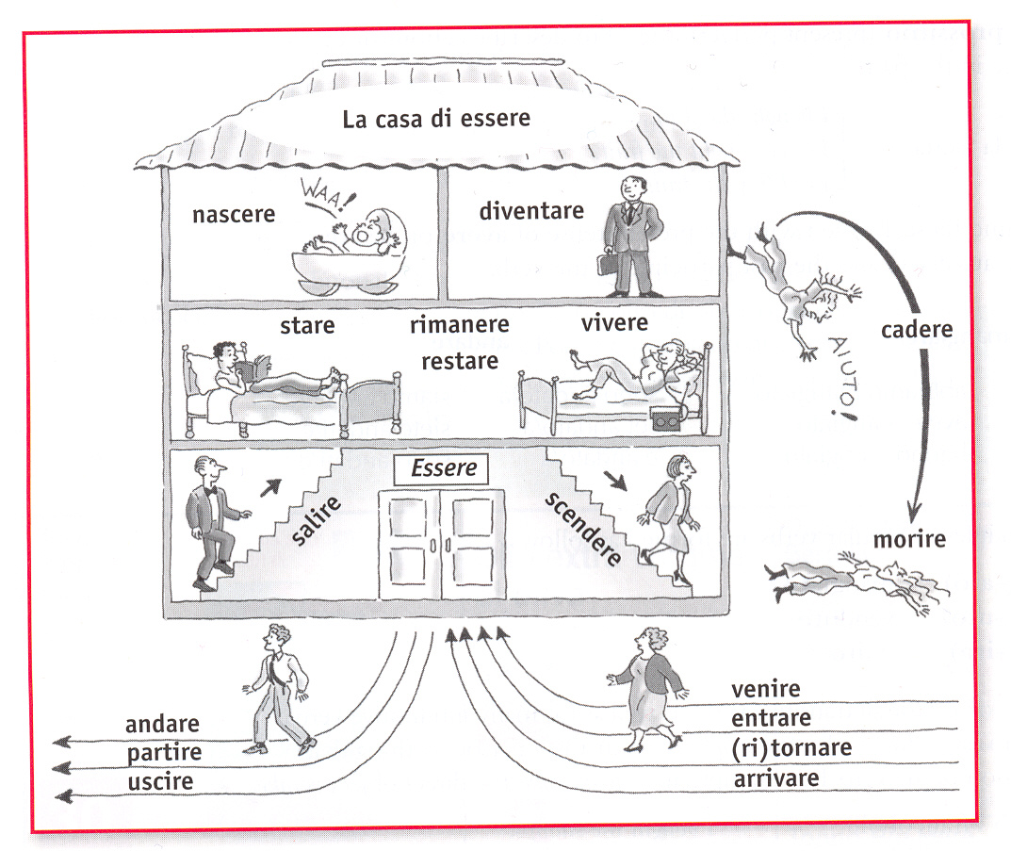
Superman Dave T.:

S (salire, scendere)
U (uscire)
P (partire)
E (essere)
R (restare, rimanere, ritornare)
M (morire)
A (andare)
N (nascere)

D (diventare)
A (arrivare)
V (venire, vivere)
E (entrare)

T (tornare)

-Regular past participles:
-are verbs – ato
-ere verbs – uto
-ire verbs – ito
-Irregular past participles:
Italian | Past participle | English
accendere | Acceso | to turn on
aprire | Aperto | to open
bere | Bevuto | to drink
chiedere | Chiesto | to ask for
chiudere | Chiuso | to close
conoscere | Conosciuto | to know
correggere | Corretto | to correct
correre | Corso | to run
decidere | Deciso | to decide
dipingere | Dipinto | to paint
dire | Ditto | to say/tell
discutere | Discusso | to discuss
essere* | Stato | to be
fare | Fatto | to do/make
leggere | Letto | to read
mettere | Messo | to put
morire* | Morto | to die
nascere* | Nato | to be born
offrire | Offerto | to offer
perdere | Perso | to lose
piangere | Pianto | to cry
prendere | Preso | to take
ridere | Riso | to laugh
rimanere* | Rimasto | to remain
rispondere | Risposto | to respond
rompere | Rotto | to break
scendere* | Sceso | to go down
scrivere | Scritto | to write
soffrire | Sofferto | To suffer
sorridere | Sorriso | to smile
spegnere | Spento | to turn off
spendere | Speso | to spend
vedere | Visto | to see
venire* | Venuto | to come
vincere | Vinto | to win
vivere* | Vissuto | to live
*starred verbs require ESSERE
When using AVERE – past participles end in –o (they don’t agree)
When using ESSERE – past participles may end in –o, -a, -e, or –i (they must agree)
Using passato prossimo with REFLEXIVE or RECIPROCAL verbs
**You must use essere
Reflexive pronoun + essere + past participles

Imperfetto
-used to discuss things that used to be, ongoing or continuous actions in the past, and past weather, ages, time, physical/emotional states of being
-Most verbs are regular and use the following endings (only remove the “RE” from the verb):
-vo -vamo
-vi -vate
-va -vano
-Irregular verbs:
-fare (face)
-dire (dice)
-bere (beve)
+regular endings

-Essere
ero eravamo
eri eravate
era erano
Possessive adjectives/pronouns
 | Masculine singular | Feminine singular | Masculine plural | Feminine plural
My | Il mio | La mia | I miei | Le mie
Your (tu) | Il tuo | La tua | I tuoi | Le tue
His/her/your (Lei) | Il suo | La sua | I suoi | Le sue
Our | Il nostro | La nostra | I nostri | Le nostre
Your (plural) | Il vostro | La vostra | I vostri | Le vostre
Their | Il loro | La loro | I loro | Le loro

** Possessive adjectives agree in gender and number with what/who is being possessed – NOT with the possessor
** Drop the article with singular family members (plurals KEEP the article)
Exceptions:
- When used with loro
- When used with mamma and papà
- Some expressions like “a casa mia”
- Modified nouns/ nouns and adjectives (la mia cara sorella, la mia sorellina)
Questo/Quello
Forms of questo:
 | Singular | Plural
Masculine | QUESTO  QUEST’ (word beginning with vowel) | QUESTI
Feminine | QUESTA  QUEST’ (word beginning with vowel) | QUESTE

Forms of quello:
 | S | P
M | QUEL  QUELLO  QUELL’ | QUEI  QUEGLI
F | QUELLA  QUELL’ | QUELLE

Comparisons/Superlatives
-Comparisons
Of Equality:
Tanto/quanto – can be used for nouns AND adjectives (must agree when comparing nouns)
Così/Come – can only be used for adjectives
Of Inequality:
Più di/meno di – two people/things, one quality
Più che/meno che – two qualities, one person/thing
-Superlatives
Il/la/I/Le + più/meno (or irregulars) + di _____________
-Irregulars:
Meglio – better (adverb)
Peggio – worse (adverb)
Migliore – better (adjective)
Peggiore – worse (adjective)
Minore – smaller, less, younger
Maggiore – greater, more, older
Futuro/Condizionale
-Futuro - Used to talk about what WILL happen
-Condizionale – Used to talk about what WOULD happen under certain circumstances
Future endings: Conditional endings:
Ò EMO EI EMMO
AI ETE ESTI ESTE
À ANNO EBBE EBBERO
Regular –ere and –ire verbs:
-drop final e
-add endings
Regular –are verbs:
-drop final e
-change “a” to “e”
-add endings
Spelling changes with –are verbs:
-ciare, -giare – drop i
-care, -gare – add h
Irregular verbs:
A doesn’t change to E RR Drop vowel Essere
dare (dar-) bere (berr-) andare (andr-) (sar-)
fare (far-) rimanere (rimarr-) avere (avr-)
stare (star-) venire (verr-) cadere (cadr-)
volere (vorr-) dovere (dovr-)
potere (potr-)
sapere (sapr-)
vedere (vedr-)
vivere (vivr-)

